Q1- Write a C program to print all alphabets from a to z ?

/\*\*\*\*\*\*\*\*\*\*\*\*\*\*\*WELCOME\*\*\*\*\*\*\*\*\*\*\*\*\*\*/

#include <stdio.h>

int main()

{

char x;

printf("Alphabets from a - z are: \n");

for(x='a'; x<='z'; x++)

{

printf("%c ", x);

}

return 0;

}

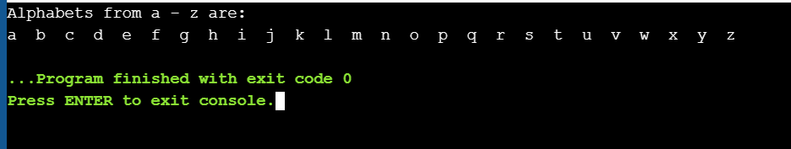OUTPUT:-

2. Write a C program to print all even numbers between 1 to 100.

/\*\*\*\*\*\*\*\*\*\*\*\*\*\*\*WELCOME\*\*\*\*\*\*\*\*\*\*\*\*\*\*/

#include<stdio.h>

int main()

{

for(int i=1;i<=100;i++)

{

if(i%2==0)

{

printf("%d ", i);

}

}

return 0;

}

OUTPUT:-

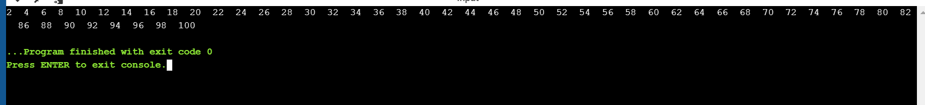

3. Write a C program to find sum of all odd numbers between 1 to n.

/\*\*\*\*\*\*\*\*\*\*\*\*\*\*\*WELCOME\*\*\*\*\*\*\*\*\*\*\*\*\*\*/

#include <stdio.h>

int main()

{

int i, n, sum=0;

printf("Enter upper limit: ");

scanf("%d", &n);

for(i=1; i<=n; i+=2)

{

sum += i;

}

printf("Sum of odd numbers = %d", sum);

return 0;

}

OUTPUT:-

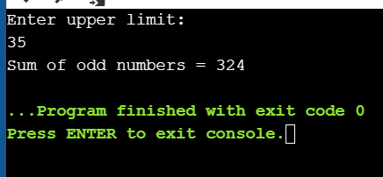

4. Write a C program to print multiplication table of any number.

/\*\*\*\*\*\*\*\*\*\*\*\*\*\*\*WELCOME\*\*\*\*\*\*\*\*\*\*\*\*\*\*/

#include <stdio.h>

int main()

{

int i, j;

printf("Enter number to print table: ");

scanf("%d", &j);

for(i=1; i<=10; i++)

{

printf("%d \* %d = %d\n", j, i, (j\*i));

}

return 0;

}

OUTPUT:-

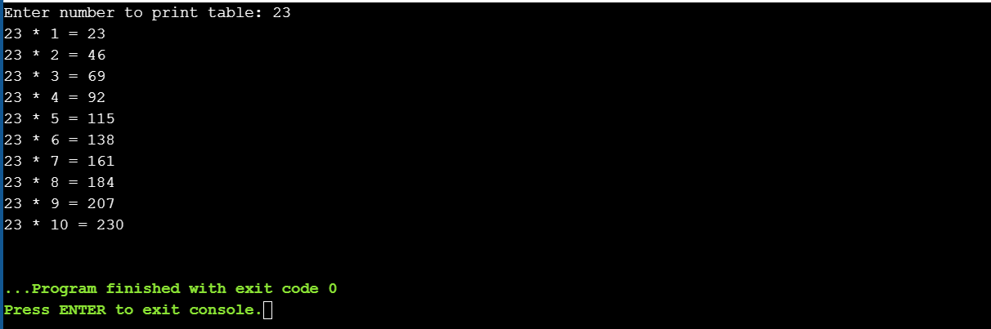

5. Write a C program to count number of digits in a number

/\*\*\*\*\*\*\*\*\*\*\*\*\*\*\*WELCOME\*\*\*\*\*\*\*\*\*\*\*\*\*\*/

#include <stdio.h>

int main()

{

long long num;

int count = 0;

printf("Enter any number: ");

scanf("%lld", &num);

do

{

count++;

num /= 10;

} while(num != 0);

printf("Total digits: %d", count);

return 0;

}

OUTPUT:-

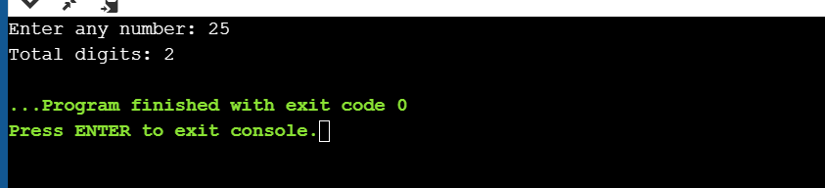

6. Write a C program to find first and last digit of a number.

/\*\*\*\*\*\*\*\*\*\*\*\*\*\*\*WELCOME\*\*\*\*\*\*\*\*\*\*\*\*\*\*/

#include <stdio.h>

#include <math.h>

int main()

{

int n, firstDigit, lastDigit, digits;

printf("Enter any number: ");

scanf("%d", &n);

lastDigit = n % 10;

digits = (int)log10(n);

firstDigit = (int)(n / pow(10, digits));

printf("First digit = %d\n", firstDigit);

printf("Last digit = %d\n", lastDigit);

return 0;

}

OUTPUT:-

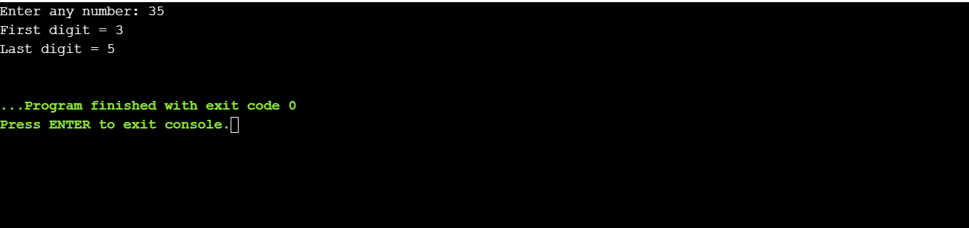

7. Write a C program to swap first and last digits of a number.

/\*\*\*\*\*\*\*\*\*\*\*\*\*\*\*WELCOME\*\*\*\*\*\*\*\*\*\*\*\*\*\*/

#include <stdio.h>

#include <math.h>

int main()

{

int num, swappedNum;

int firstDigit, lastDigit, digits;

printf("Enter any number: ");

scanf("%d", &num);

lastDigit = num % 10;

digits = (int) log10(num);

firstDigit = (int) (num / pow(10, digits));

swappedNum = lastDigit;

swappedNum \*= (int) round(pow(10, digits));

swappedNum += num % ((int)round(pow(10, digits)));

swappedNum -= lastDigit;

swappedNum += firstDigit;

printf("Original number = %d\n", num);

printf("Number after swapping first and last digit: %d\n", swappedNum);

return 0;

}

OUTPUT:-

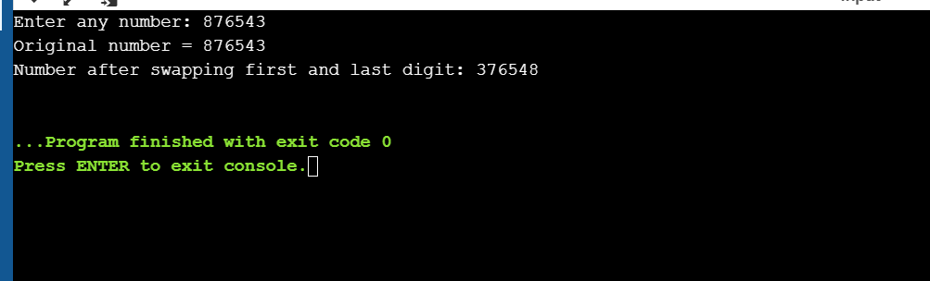

8. Write a C program to find frequency of each digit in each integer.

/\*\*\*\*\*\*\*\*\*\*\*\*\*\*\*WELCOME\*\*\*\*\*\*\*\*\*\*\*\*\*\*/

#include <stdio.h>

#define BASE 10 /\* Constant \*/

int main()

{

long long num, n;

int i, lastDigit;

int freq[BASE];

printf("Enter any number: ");

scanf("%lld", &num);

for(i=0; i<BASE; i++)

{

freq[i] = 0;

}

n = num;

while(n != 0)

{

lastDigit = n % 10;

n /= 10;

freq[lastDigit]++;

}

printf("Frequency of each digit in %lld is: \n", num);

for(i=0; i<BASE; i++)

{

printf("Frequency of %d = %d\n", i, freq[i]);

}

return 0;

}

Output:-

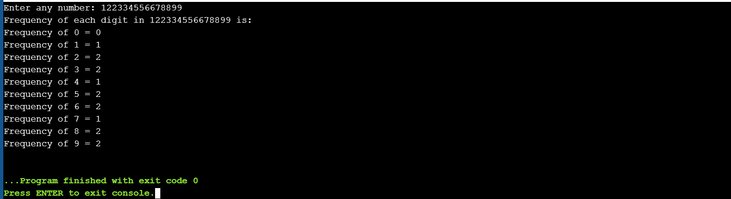

9. Write a C program to enter a number and print it in words.

/\*\*\*\*\*\*\*\*\*\*\*welcome\*\*\*\*\*\*\*\*\*\*\*\*/

#include <stdio.h>

#include <math.h>

int main()

{

int n, num = 0, digits;

printf("Enter any number to print in words: ");

scanf("%d", &n);

digits = (int) log10(n);

while(n != 0)

{

num = (num \* 10) + (n % 10);

n /= 10;

}

digits = digits - ((int) log10(num));

while(num != 0)

{

switch(num % 10)

{

case 0:

printf("Zero ");

break;

case 1:

printf("One ");

break;

case 2:

printf("Two ");

break;

case 3:

printf("Three ");

break;

case 4:

printf("Four ");

break;

case 5:

printf("Five ");

break;

case 6:

printf("Six ");

break;

case 7:

printf("Seven ");

break;

case 8:

printf("Eight ");

break;

case 9:

printf("Nine ");

break;

}

num /= 10;

}

while(digits)

{

printf("Zero ");

digits--;

}

return 0;

}

OUTPUT:-

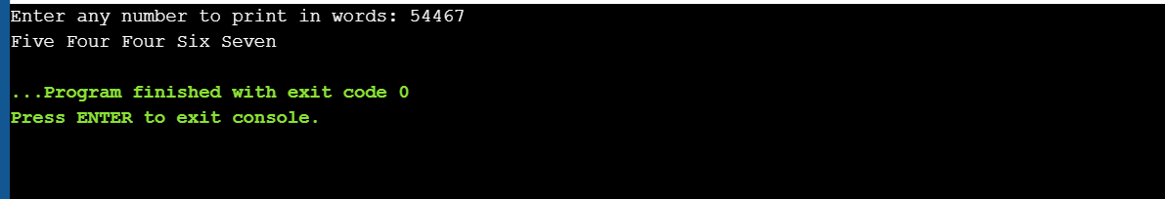

10. Write a C program to print all ASCII character with their values.

/\*\*\*\*\*\*\*\*\*\*\*\*WELCOME\*\*\*\*\*\*\*\*\*\*\*\*/

#include <stdio.h>

int main()

{

int i;

for(i=0; i<=255; i++)

{

printf("ASCII value of character %c = %d\n", i, i);

}

return 0;

}

OUTPUT :-

